87750477193

ӘДІҚАДЫРОВА Ғазиза Ердаулетқызы,
Нұр-Болашақ-2 мектебінің ағылшын тілі пәні мұғалімі.
Түркістан облысы, Түркістан қаласы

OLYMPIC GAMES

Learning objectives(s) that this lesson is contributing to |  | - Pronounce sounds new words;  - To train new words and discussion an English language;  - To develop the pupils habits of the oral speech.
Lesson objectives |  | All learners will be able to:
- Read and retell a piece of text.
- Spell topic-related words correctly.
Most learners will be able to:
- Know translation of new words.
- Remember the information from the text.
Some learners will be able to:
- Write answers of worksheets.
Success criteria |  | To name 10 types of the Olympic games and pronounce new words
Value links |  | Healthy lifestyle, Respect, Support, Trust
Cross curricular links |  | PE, Psychology, sociology
ICT skills |  | Projector or Smart board, PPT
Previous learning |  | I want to be healthy. Food
Plan
Planned timings | Planned activities (replace the notes below with your planned activities) |  | Resources
Beginning  5 min  5 min | Organizational moment  The teacher greets the students and asks questions to them.  -Good afternoon!  -Good afternoon!  -How are you?  -We are fine, thank you!  Warm up :  Showing video “ If you happy and you know it clap your hands”  Homework :  Pupils , what was your homework for today  Showing pictures from interactive board.  Tell students they have to look at the pictures and find names of pictures  Assessment criteria Descriptor  Olympic games  - Say translation of words Archery-садақпен ату  Fencing-семсерлесу  Rugby- регби  Gymnastics-гимнастика  Handball-гандбол  Longjump-ұзындыққа секіру  Figure skating-мәнерлеп сырғанау  Water polo - су добы |  | http://www.youtube.com/watch  PPT  https://www.youtube.com/watch?v=xucvTv5pa9A
5 min | Opening new lesson:  Showing video about new theme and learners will find names of the new theme  Learners divided into three groups. They need to choose cards and names of their group.  Volleyball Football Tennis  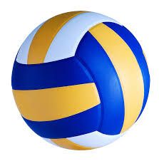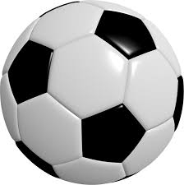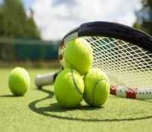
Middle  10 min  10 min  10 min | Exercise 1. Listen and repeat : oo- short [u:], long [ʊ]  Learners have to look at the blackboard and listen sounds and words pronunciation.  Learners open your copybooks and write new words.  Assessment criteria Descriptor  Archery-садақпен ату  Fencing-семсерлесу  Rugby- регби  Gymnastics-гимнастика  Handball-гандбол  Longjump-ұзындыққа секіру  Figure skating-мәнерлеп сырғанау  Water polo - су добы  Archery-садақпен ату  Exercise 2. Read.  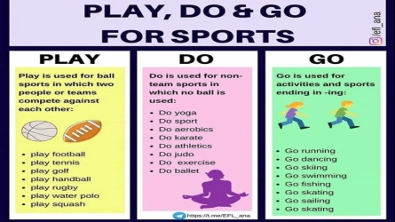  Assessment criteria Descriptor  A learner  Match - Go bowling  - Play football  - Go swimming  - Do yoga  - Do judo  - Play tennis  - Go skating  - Do karate  - Play handball  Exercise 3. Reading. Read and Complete.  archery really handball  I do fencing (1) ____ well. I have got a gold medal from the London Olympics in 2013 and a have got two silver medals from the Brazil Olympics in 2014. I do (2) ___ and I play (3)_______ easily.  Assessment criteria Descriptor  A learner  Find words which pronounce with sound oo - Really  - Archery  - handball  Exercise 4. Listening. What sport do they play well? Listen and write.  Water polo, cycling, handball, gymnastics  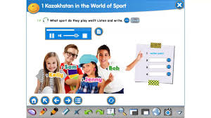  Assessment criteria Descriptor  A learner  Listen and write. Water polo, cycling, handball, gymnastics - Kelly: water polo - Sam: cycle - Jenny: Handball - Bob: Gimnastics |  | https://www.youtube.com/watch?v=hDJQM9XxsCc
End  3 min |   
Reflection  2 min | Learners will write their names and will make decision.  Lesson was …  